SOCIO-ECONOMIC IMPACT OF MICRO HYDROPOWER PLANTS AND THEIR CONTRIBUTION TO LOCAL DEVELOPMENT.
Olimov Jamshidbek Khurshid og’li
Fergana Polytechnic Institute, 2nd year student, jambek1057121@gmail.com
ABSTRACT
This article examines the socio-economic impact of micro hydropower plants and their contribution to local development, the advantages and disadvantages of micro hydropower plants. It is shown that they do not harm the environment and help maintain ecological balance. Micro hydropower plants are one of the renewable energy sources, contributing to the diversification of the country's energy sources and reducing dependence on natural gas. The benefits of micro hydropower plants for Uzbekistan. The contribution of micro hydropower plants to the economy of cities is shown. Our main goal: to effectively use the energy of micro hydropower plants in socio-economic and local development.
Keywords : micro, hydroelectric power, pressure, hydro turbine .
ENTRANCE
Micro hydropower plants are small-scale hydroelectric power plants that can make a significant contribution to social and economic development by generating electricity at a local level. Micro hydropower is a technology for generating electricity with minimal environmental impact using very small amounts of resources . Depending on its installed capacity, it is sufficient to meet the electricity needs of a few households, a small workshop or a neighborhood (depending on its capacity, it can produce even more electricity).
The principle of operation of a micro hydroelectric power plant : The main factor in the operation of any micro hydroelectric power plant is hydrostatic pressure and water flow. Hydrostatic pressure is measured by the height of the water level entering the hydroelectric power plant above the center of the turbine impeller. Water flow is an indicator of how many cubic meters of water are delivered to the turbine per second . Hydrostatic pressure allows the water flow to be directed sharply downward, like a waterfall. In this case, the water rotates the turbine shaft at high speed and is transmitted to the generator shaft, and as a result, the generator produces current.
This article aims to study the social impact (improvement of energy supply and quality of life) and economic contribution (job creation, development of entrepreneurship) of micro hydropower plants. The ability to prevent environmental damage to reservoirs during the construction of hydropower plants , the small capital costs for the construction of plants, and the possibility of a quick return on capital costs (up to 5 years) have fueled the development of micro energy worldwide in recent decades.
In our republic to widely introduce small-capacity renewable energy sources, including micro and small hydropower plants. In particular, this micro-hydropower plant, built on the banks of the Koksuv River, which passes through the settlement of Shohimardon in the Fergana region, has 2 hydroelectric units installed, through which an average of 13 million kWh of electricity is produced per year. As a result, it will be possible to save 3.5 million cubic meters of natural gas per year and provide 5,400 households with electricity. For information: today, 7,000 people live in 1,205 households in the village of Shohimardon. This micro-hydroelectric power plant can supply electricity to rural residents even when disconnected from the central grid. In 2023, 9.8 million kWh of electricity was consumed by the region's residents and more than 40 wholesale consumers . Now, an average annual increase of 3.2 million kWh of electricity is expected from local consumers. In addition , the 430 kWh "Vodil" micro-hydroelectric power plant was commissioned. Its annual production capacity is 2.17 million kWh, which will fully provide 904 households, that is, the population living in the "Upper Vodil" MPY, with environmentally friendly electricity. As a result of the commissioning of this micro-hydroelectric power plant, an average of 615 thousand cubic meters of natural gas will be saved per year. 6 new jobs were created through the commissioning of the project. For information: 869.6 thousand kWh of electricity was consumed by 1,907 consumers in the Yuqori Vadil MFE in 2023. As a result of the commissioning of this micro-hydroelectric power plant, an average annual 1.3 million kWh of electricity will be supplied from the mahalla to consumers in the neighboring Boston and Obod mahallas.
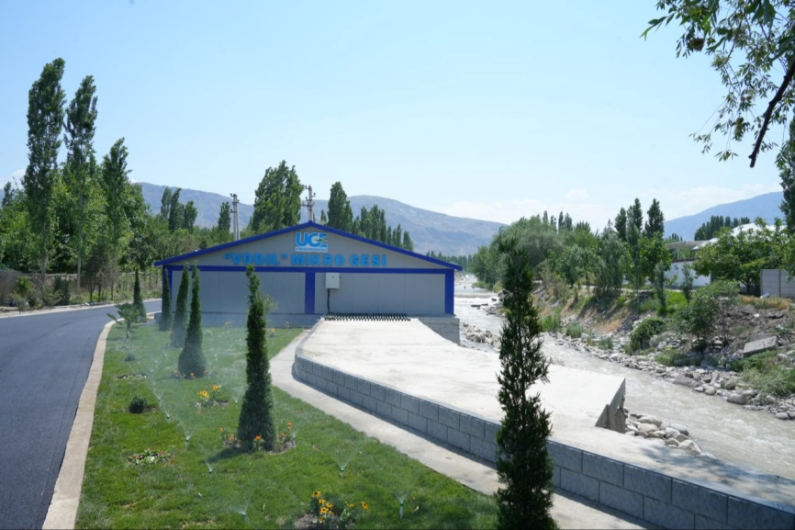
Figure 1. "VODIL"Micro hydroelectric power plant.

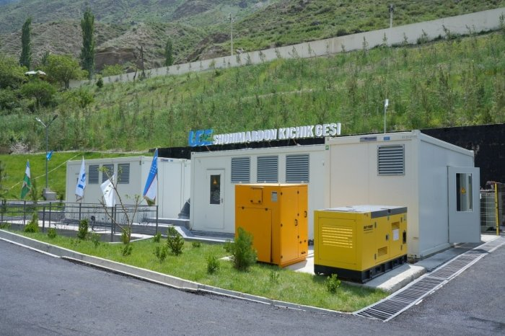
Figure 2. Shahimardon small hydroelectric power plant.
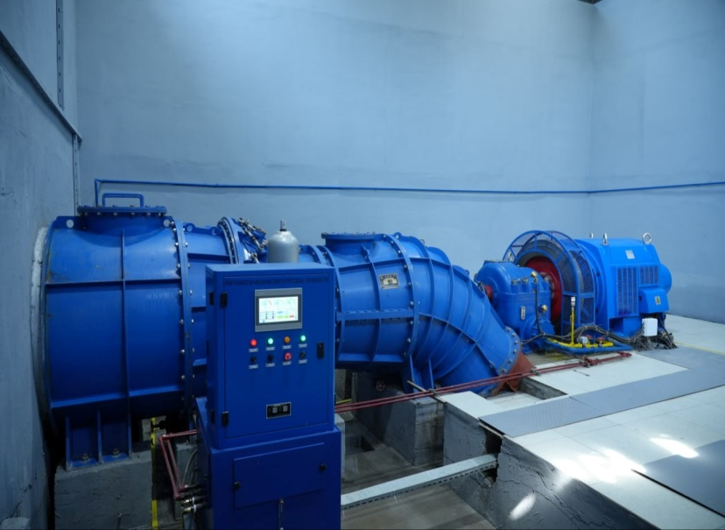
Figure 3. Micro hydroelectric turbine.
have shown that micro hydropower plants are effective in solving energy supply problems in rural areas . At the same time, micro hydropower plants are being recognized as one of the main tools for stimulating local economies in developing countries.
METHODOLOGY
- For this article, the social and economic impact was studied using the example of micro hydropower projects in the Fergana Valley.
- statistical data analysis and interviews with local residents .
- and local organizations about micro-hydropower plants in the Fergana Valley, an analysis of electricity production, supply to the population, and economic benefits was conducted.
- A model was created using computer programs to assess the long-term social and economic efficiency of micro hydropower plants .
to study the electricity generated and economic impact indicators of 2 micro hydropower plants in the Fergana Valley . More than 100 local residents and business representatives were interviewed through questionnaires. In addition, Excel and MATLAB programs were used to model the long-term efficiency of micro hydropower plants.

RESULTS
According to the results of the study , micro hydropower plants in the Fergana Valley:
- electricity demand by 25%.
- Created about 100 new jobs.
- Helped increase local entrepreneurship by 10%.
- have increased production using micro-hydropower .
According to the study , micro-hydropower plants have provided affordable and stable electricity to local residents, increasing energy security. As a result of the construction of micro-hydropower plants, power outages have been significantly reduced (by 50% due to an increase in demand). Thanks to micro-hydropower plants in the regions, 100 new jobs have been created, which has had a positive impact on the local economy and stimulated the development of agriculture and small businesses.

ANALYSIS
Micro hydropower plants contribute to sustainable development, but:
- Investment demand is high.
- technical service and equipment delivery are urgent.
Although micro hydropower plants in Fergana have shown high efficiency , they have maintenance and initial investment challenges. However, as they develop, they have proven to bring significant benefits to local communities.
China and India shows that such projects stabilize energy supplies in the long term and support local development.
The results of this study are consistent with the experiences of micro hydropower in China and India, as they develop local economic activities in the long term. However, the problem of maintenance and initial investment remains relevant in most projects. In the Fergana Valley, micro hydropower can be seen as an important factor in ensuring local economic growth and environmental sustainability.

CONCLUSION
Micro hydropower plants play a key role in local economic and social development.
It is of great importance in ensuring environmental safety.
- To develop micro hydropower plants:
- State support plays a very important role.
- Improving technical knowledge and strengthening them is considered very useful and important.
are an effective means of supporting energy and economic development at the local level. This project is economically sustainable and environmentally friendly, helping to improve the quality of life of local communities. It is recommended to introduce micro hydropower plants on a larger scale. Research has proven the positive impact of micro hydropower plants on local development . They can increase the stability of energy supply, create new jobs and develop the local economy. At the same time, the issues of initial investment and maintenance need to be addressed. It is advisable to implement these projects on a large scale by involving local authorities and investors.

REFERENCES
- https://yuz.uz/uz/news/fargona-viloyatida-ikkita-mikro-gidroelektr- stancymali-ishga-tushirildi
- https://cyberleninka.ru/article/n/o-uzbekistan-energetikasida-mikro-hes-tgan-rni-va-larnarin-rovijlanish-sida
- https://minenergy.uz/uz/news/view/4094
- https://minenergy.uz
- http://uzgidro.uz
- http://uzbekgidroenergoqurilish.uz/uz/

